Will Quantum Technology be relevant in Future Displays?

Can Quantum Technology improve Displays?

**Meta**

*This article explains and evaluates new display technologies based on quantum dot semiconductors. For this, biologically reasoned criteria are introduced and used to compare these new technologies to current successful methods.*

One thing is sure. Our digitalised world wouldn’t be possible without displays and the demand for energy efficient, cheap and realistic presentation of information is higher than ever. The most successful display technologies currently on the market are LCD and OLED displays but tech companies like Samsung already started to introduce so called QLED TV’s. Sounds close to OLED you might think, but the difference is more fundamental than the name suggests. The new technology here is the use of so called Quantum Dots for the colour instead of e.g organic materials in OLEDs

Lets dive quickly into the relevant physics.

In semiconductors there is a range of energies the electrons can’t have, the so called band gap. This band gap usually separates the mostly filled energy states which are the valence electrons that bind the atoms of the material and the higher and mostly empty energy states of conducting electrons. ~~These energy states are also called valence band and conduction band.~~ A quantum dot is a often spherical piece of semiconductor, for example cadmium sulfide (CdS), that with size in the range of nanometres. In that regime its band gap changes significantly from its initial value. For example in the case of CdS, which typically has a band gap of 2.6eV the band gap can be increased up to 3.5eV [Brus1998].

If an electron of a higher energy state changes into a lower energy state, the energy difference is emitted as light of a certain wavelength $\lambda$ given by $E=\frac{h}{\lambda}. By varying the size of the quantum dots it is possible to create materials that can emit almost any colour [ElectronElectronBrus]. ~~Also, the light emitted by this process is very pure compared to conventional methods~~

Our eye perceives colour over so called cones, sensors for red, green and blue light. An ideal display matches our natural perception of objects by transmitting a mixture of these three colours. The set of colours a display can represent is the colour gamut that can be represented in the so called CIE 1932 chromaticity diagram shown in figure [fig]. Colours close to the edge have single wavelengths and going to the middle we find mixtures of these colours. The gamut of a display is represented by the area of the triangle between the three primary colours as shown in figure . The wider the gamut the colourful display seems to us.

Quantum dots emit light with very narrow peak widths compared to typical organic emitters in OLEDs or color spectra from lcd screens. This makes it possible to achieve much wider gamuts than currently on the market.

Other factors of consideration are also the brightness of the display and its operational lifetime.

The brightness of the emitted light is strongly dependent on the Quantum Yield? Efficiency? Operational lifetimes can be extended by coating the quantum dots in other semiconductor materials that additionally should not react with surrounding materials

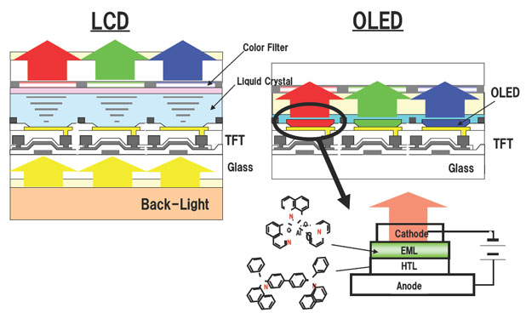

This mechanism can be implemented into displays in two different ways. The first way is the down conversion of blue light into green and red light, also called photoluminescence. The incoming blue photon excites an electron over the band gap. Usually, the photon doesn’t recombine directly but looses energy to the semiconductor lattice until it reaches the band gap. From there it recombines with the free electron state it created and emits a photon of the color corresponding to the band gap width.

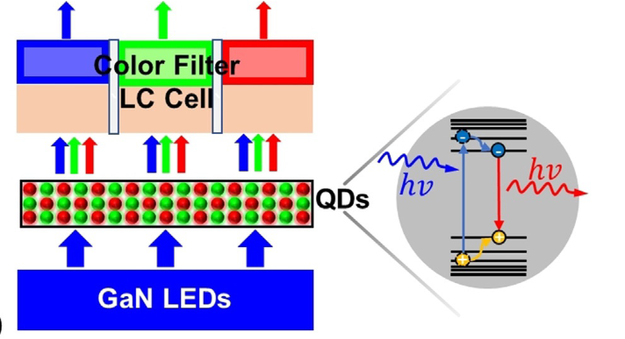 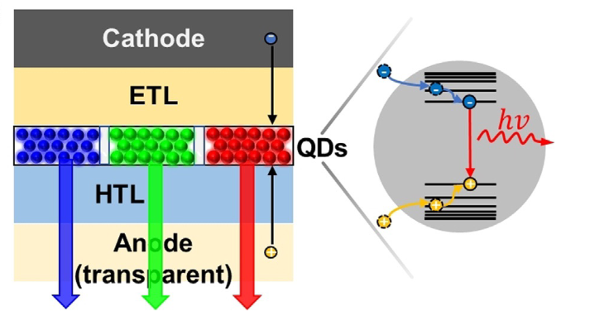

The colour gamut of LCD screens, which work on a white backlight with colour filters for red and green colour can be improved significantly by using quantum dots. In a first step currently marketed by Samsung as QLED TV’s [ref], a blue LED light source is combined with a layer of colloidal quantum dots for green and red colour instead of yellow phosphor. This makes possible a wide colour gamut but can only be a intermediate solution. The light source still creates much more light than is used in the end [Shu]. Also, the contrast, the maximal difference in brightness on the screen is limited by the remains of backlight coming through switched off pixels. This is a large disadvantage to OLED screens which can switch of pixels completely and thus also save additional power. [µLEDLiu]

*µLED’s?*

A second more advanced approach would be to replace the filtering for each colour by a film of corresponding quantum dots [ctarticle]

Instead of the colour filters, quantum dots for the right colour are dispersed in a polymer solution and which is then placed in the pixel

So, to produce a colour from a quantum dot one only needs to introduce excited electrons and corresponding free states in the quantum dot.

**Physical Requirements of a Display**

Color gamut, Brightness, Operational lifetime

**Explain physical functionality of the different methods**

Spectral differences to other methods

Backlit Qdot displays:

* Samsung QLED (QD-LCD), QD-µLED
  + Structural implementation
* Advantages:
* Disadvantages:

Self Emitting Quantum dots:

* True QLEDs
* Comparison to OLEDs

Describe optimal parameters for a good display

* Color gamut
* Color stability
* Energy efficiency
* Possibility for downscaling

How can Quantum Dots emit light?